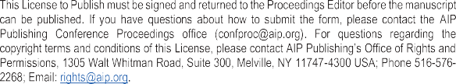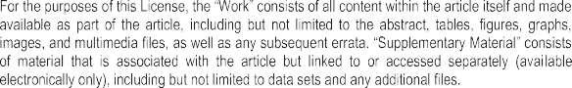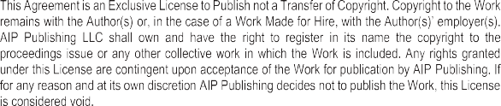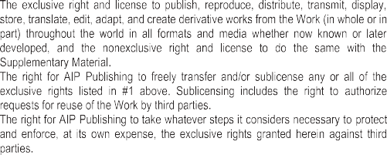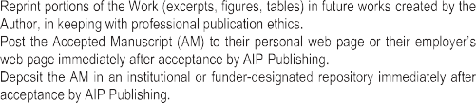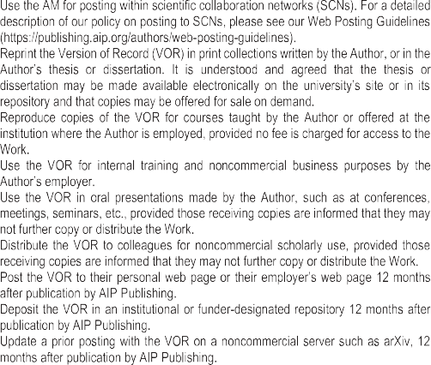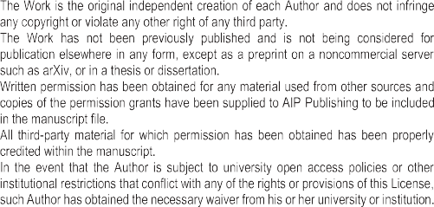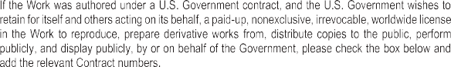



Utilization of Waste Ceramic Powder as a Substitute of Fine Aggregate and Addition of Zinc Fiber to Increase the Split Tensile Strength of Concrete

Authors,

Lolom Evalita Hutabarata), Jhon Cipta D. Hulub) and Risma Simanjuntakc)

Department of Civil Engineering, Faculty of Engineering, Universitas Kristen Indonesia (UKI), Jakarta Indonesia

a) Corresponding authors: Lolom.Hutabarat@uki.ac.id

b) jhonhulu983@gmail.com

c) risma.simanjuntak@uki.ac.id

Title of Conference: Sriwijaya International Conference on Engineering and Technology (SICETO)

Name of Editor: Dendy Adanta



Lolom Evalita Hutabarat Oct 16, 2021

Author’s signature Print name Date





